**1 MARK MCQs**

What is the main principle of OOP?

A) Inheritance

B) Encapsulation

C) Polymorphism

D) Abstraction

Answer: E) All of the above

Which concept ensures that a class should not reveal its internal implementation?

A) Inheritance

B) Encapsulation

C) Polymorphism

D) Abstraction

Answer: B) Encapsulation

Which OOP concept allows one class to inherit properties and behavior from another class?

A) Abstraction

B) Polymorphism

C) Inheritance

D) Encapsulation

Answer: C) Inheritance

In C++, a class's constructor is called when:

A) A class object is declared

B) A class object is created

C) A class is declared

D) A class is defined

Answer: B) A class object is created

What does the term 'polymorphism' mean in OOP?

A) Ability to access multiple classes at once

B) Ability to write multiple methods within a class

C) Ability to have multiple forms

D) Ability to hide implementation details

Answer: C) Ability to have multiple forms

Which OOP feature allows methods with the same name but different parameters to be defined within the same class?

A) Inheritance

B) Encapsulation

C) Polymorphism

D) Abstraction

Answer: C) Polymorphism

In OOP, a derived class inherits:

A) Data members and member functions from the base class

B) Only data members from the base class

C) Only member functions from the base class

D) Constructors from the base class

Answer: A) Data members and member functions from the base class

Which keyword in C++ is used to implement data hiding?

A) this

B) friend

C) public

D) private

Answer: D) private

Which OOP principle focuses on reusing code by creating new classes based on existing ones?

A) Inheritance

B) Encapsulation

C) Polymorphism

D) Abstraction

Answer: A) Inheritance

Which OOP principle ensures that a class only allows access to a limited set of members to the outside world?

A) Abstraction

B) Encapsulation

C) Polymorphism

D) Inheritance

Answer: B) Encapsulation

In OOP, what is an abstract class?

A) A class with only private members

B) A class that cannot have objects instantiated from it

C) A class with no member functions

D) A class with only static methods

Answer: B) A class that cannot have objects instantiated from it

Which OOP feature allows a class to have multiple methods with the same name but different parameters?

A) Inheritance

B) Encapsulation

C) Polymorphism

D) Abstraction

Answer: C) Polymorphism

What is the concept of 'method overloading' in OOP?

A) Redefining a method in a derived class

B) Creating methods with the same name but different parameters in the same class

C) Accessing methods from a base class in a derived class

D) Creating private methods within a class

Answer: B) Creating methods with the same name but different parameters in the same class

Which keyword is used to prevent a method from being overridden in a derived class in C++?

A) override

B) final

C) virtual

D) constant

Answer: B) final

In OOP, what does the term 'composition' refer to?

A) Creating objects from classes

B) Inheriting properties from multiple classes

C) Including objects of other classes within a class

D) Using static methods in a class

Answer: C) Including objects of other classes within a class

What is the process of creating a new class from an existing class called in OOP?

A) Cloning

B) Creating

C) Instantiating

D) Inheriting

Answer: D) Inheriting

In OOP, which access specifier allows the members of a class to be accessed from outside the class?

A) public

B) private

C) protected

D) friend

Answer: A) public

What is the purpose of a destructor in a C++ class?

A) To allocate memory for class objects

B) To initialize class members

C) To deallocate memory and perform cleanup tasks when an object is destroyed

D) To define the number of objects that can be created from a class

Answer: C) To deallocate memory and perform cleanup tasks when an object is destroyed

Which OOP concept allows a class to inherit from multiple base classes?

A) Inheritance

B) Encapsulation

C) Polymorphism

D) Multiple Inheritance

Answer: D) Multiple Inheritance

Which feature of OOP allows a class to have more than one method with the same name but different parameters?

A) Inheritance

B) Encapsulation

C) Polymorphism

D) Overloading

Answer: D) Overloading

In OOP, what is an interface?

A) A class that cannot be instantiated

B) A blueprint for a class that specifies a set of methods to be implemented

C) A class with private members only

D) A class with static methods only

Answer: B) A blueprint for a class that specifies a set of methods to be implemented

Which keyword in C++ is used to indicate that a method in a base class is intended to be overridden in a derived class?

A) override

B) virtual

C) final

D) extends

Answer: B) virtual

What is the purpose of the 'this' pointer in C++?

A) It points to the base class in inheritance

B) It points to the derived class in inheritance

C) It points to the current object

D) It points to the parent object

Answer: C) It points to the current object

Which OOP principle allows a class to inherit properties and behavior from more than one class?

A) Inheritance

B) Encapsulation

C) Polymorphism

D) Multiple Inheritance

Answer: D) Multiple Inheritance

What is the purpose of a pure virtual function in C++?

A) It cannot be overridden in a derived class

B) It has no implementation in the base class and must be implemented in derived classes

C) It can be called directly without creating objects

D) It can only be accessed from the base class

Answer: B) It has no implementation in the base class and must be implemented in derived classes

In OOP, what does the term 'dynamic binding' refer to?

A) Resolving function calls at compile-time

B) Resolving function calls at runtime

C) Binding methods to classes

D) Binding objects to classes

Answer: B) Resolving function calls at runtime

Which OOP principle emphasizes the ability of a class to take on multiple forms?

A) Encapsulation

B) Polymorphism

C) Abstraction

D) Inheritance

Answer: B) Polymorphism

What does the 'protected' access specifier in a C++ class signify?

A) Members are accessible only within the class

B) Members are accessible within the class and derived classes

C) Members are accessible outside the class

D) Members are accessible globally

Answer: B) Members are accessible within the class and derived classes

Which OOP concept involves using a single name to define different functions?

A) Overloading

B) Inheritance

C) Encapsulation

D) Polymorphism

Answer: A) Overloading

Recursion in programming refers to:

A) A loop that repeats a block of code

B) A function calling itself

C) Breaking down a problem into smaller subproblems

D) Declaring multiple functions with the same name

Answer: B) A function calling itself

The function that calls itself in a recursive process is known as the:

A) Parent function

B) Subsidiary function

C) Recursive function

D) Auxiliary function

Answer: C) Recursive function

Which of the following is required for a recursive function?

A) A loop structure

B) A base case

C) An iterative statement

D) A function prototype

Answer: B) A base case

What is the base case in recursion?

A) The case when the function has multiple return statements

B) The case when the function is called for the first time

C) The case that terminates the recursive process

D) The case where the function has the smallest input

Answer: C) The case that terminates the recursive process

Which of the following problems is well-suited for solving with recursion?

A) Calculating factorial

B) Implementing a sorting algorithm

C) Parsing a string

D) Matrix multiplication

Answer: A) Calculating factorial

What is the process in which a function calls itself directly or indirectly is called?

A) Self-calling

B) Self-execution

C) Recursive calling

D) Function iteration

Answer: C) Recursive calling

Recursion can lead to:

A) Efficient memory management

B) Stack overflow

C) Improved performance

D) Reduced program complexity

Answer: B) Stack overflow

The function that terminates the recursion process is referred to as the:

A) Anchor function

B) Starting function

C) Base function

D) Terminal function

Answer: C) Base function

What is an array in C++?

A) A collection of different data types

B) A collection of variables of the same data type

C) A built-in function

D) A class used for data manipulation

Answer: B) A collection of variables of the same data type

The index of the first element in a C++ array is:

A) 1

B) 0

C) -1

D) Depends on the size of the array

Answer: B) 0

How do you declare a one-dimensional array in C++?

A) array myArray[];

B) int myArray[];

C) myArray[] = new array;

D) int myArray[SIZE];

Answer: D) int myArray[SIZE];

What is a stack in C++?

A) A data structure that follows FIFO (First-In-First-Out) order

B) A data structure that follows LIFO (Last-In-First-Out) order

C) A sorting algorithm

D) A data structure that arranges elements in ascending order

Answer: B) A data structure that follows LIFO (Last-In-First-Out) order

Which operation adds an element to the top of a stack in C++?

A) push()

B) add()

C) insert()

D) append()

Answer: A) push()

In a stack, removing an element from the top is done using which operation?

A) pop()

B) remove()

C) delete()

D) extract()

Answer: A) pop()

What does STL stand for in C++?

A) System Template Library

B) Standard Template Library

C) Structured Template Library

D) Static Template Library

Answer: B) Standard Template Library

Which header file is used to include vectors in C++ STL?

A) <list>

B) <vector>

C) <map>

D) <stack>

Answer: B) <vector>

Which STL container is used to implement a Last-In-First-Out (LIFO) data structure?

A) set

B) map

C) stack

D) queue

Answer: C) stack

In STL, which algorithm is used to find the maximum element in a container?

A) find_max()

B) max_element()

C) maximum()

D) find_maximum()

Answer: B) max_element()

What does the 'push_back()' function do in a vector container of the STL?

A) Adds an element to the front of the vector

B) Adds an element to the back of the vector

C) Removes an element from the front of the vector

D) Removes an element from the back of the vector

Answer: B) Adds an element to the back of the vector

In STL, which algorithm is used to sort elements in a container?

A) order()

B) sort()

C) arrange()

D) organize()

Answer: B) sort()

What does the 'pop()' function do in a stack container of the STL?

A) Adds an element to the stack

B) Removes the top element from the stack

C) Removes the bottom element from the stack

D) Retrieves the top element from the stack without removing it

Answer: B) Removes the top element from the stack

Which keyword is used to throw an exception explicitly in C++?

A) catch

B) throw

C) try

D) throws

Answer: B) throw

Which block is mandatory to accompany a 'try' block in C++ exception handling?

A) catch

B) throw

C) finally

D) exception

Answer: A) catch

What is the purpose of the 'catch' block in C++ exception handling?

A) To throw exceptions

B) To define the block of code where an exception might occur

C) To handle exceptions thrown by the 'try' block

D) To finalize code execution

Answer: C) To handle exceptions thrown by the 'try' block

How does the 'throw' statement work in C++?

A) It terminates the program execution

B) It generates an error message

C) It transfers control to the nearest 'catch' block

D) It initializes an exception object

Answer: C) It transfers control to the nearest 'catch' block

Which standard header file provides the base class 'exception' for all standard C++ exceptions?

A) <stdexcept>

B) <iostream>

C) <exception>

D) <stdlib.h>

Answer: C) <exception>

Which of the following operators cannot be overloaded in C++?

A) +

B) =

C) *

D) ::

Answer: D) ::

How is the addition operator '+' overloaded for a custom class 'A' in C++?

A) A operator+(A obj)

B) operator+(A obj1, A obj2)

C) A operator+(A obj1, A obj2)

D) A + operator(A obj)

Answer: C) A operator+(A obj1, A obj2)

**2 mark questions**

What happens when you try to pop an element from an empty stack?

A) The program crashes

B) An error message is displayed

C) The program removes the last element added

D) Nothing, the stack remains unchanged

Answer: A) The program crashes

Which STL container automatically sorts its elements when a new element is added?

A) map

B) unordered_map

C) set

D) unordered_set

Answer: C) set

What is the advantage of using recursion?

A) Recursion is more memory-efficient than iteration

B) Recursion simplifies code readability

C) Recursion can solve certain problems more intuitively

D) Recursion is faster than iteration

Answer: C) Recursion can solve certain problems more intuitively

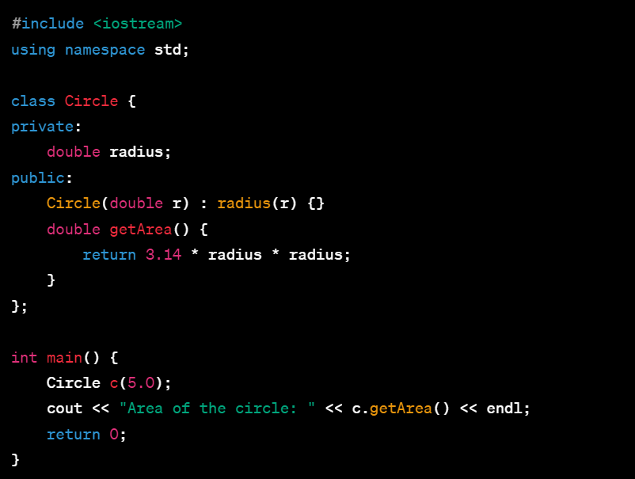

What is the accessibility of the radius member variable in the Circle class?

A) Public

B) Private

C) Protected

D) Friend

Answer: B) Private

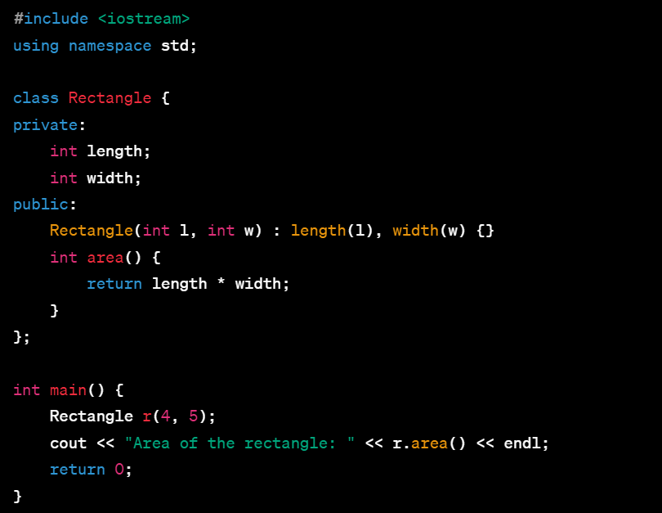

What does the area() function in the Rectangle class calculate?

A) Perimeter of the rectangle

B) Diagonal length of the rectangle

C) Volume of the rectangle

D) Area of the rectangle

Answer: D) Area of the rectangle

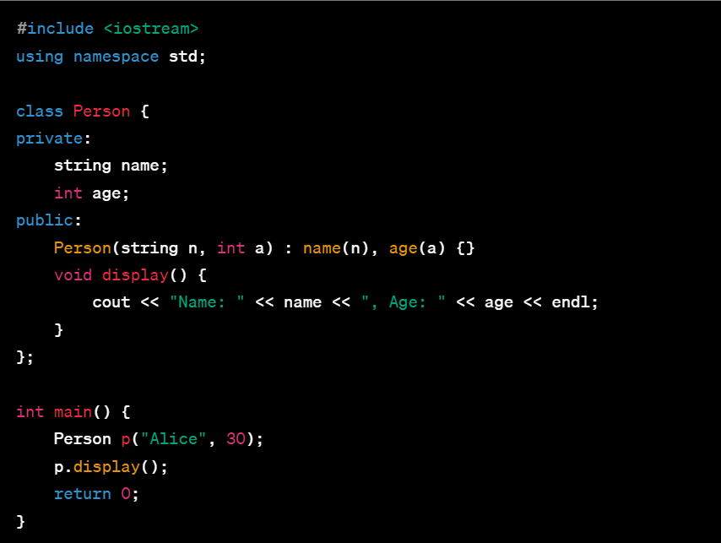

What information does the display() function in the Person class print?

A) Name only

B) Age only

C) Both name and age

D) Address of the person

Answer: C) Both name and age

Which standard exception class in C++ is used to catch all exceptions?

A) runtime_error

B) logic_error

C) exception

D) stdexcept

Answer: C) exception

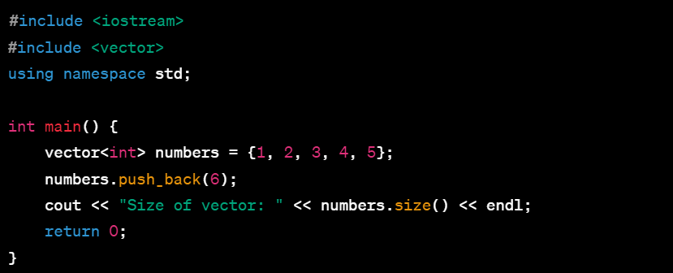

What is the output of the code snippet?

A) Size of vector: 5

B) Size of vector: 6

C) Size of vector: 7

D) Error: Vector out of range

Answer: C) Size of vector: 6

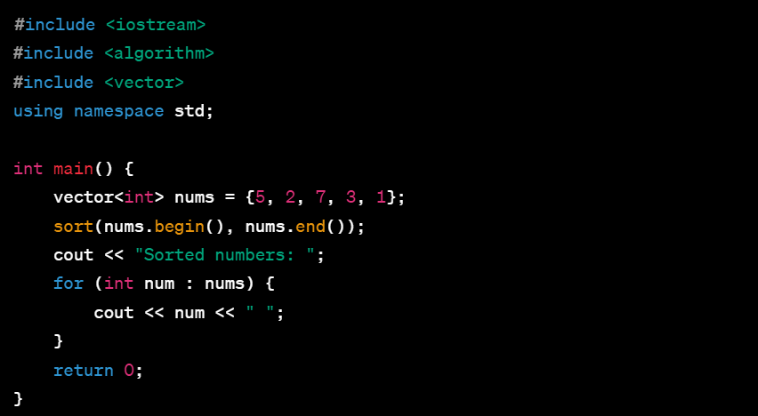

What is the output of the code snippet?

A) Sorted numbers: 5 2 7 3 1

B) Sorted numbers: 1 2 3 5 7

C) Sorted numbers: 7 5 3 2 1

D) Error: Sort function not defined

Answer: B) Sorted numbers: 1 2 3 5 7

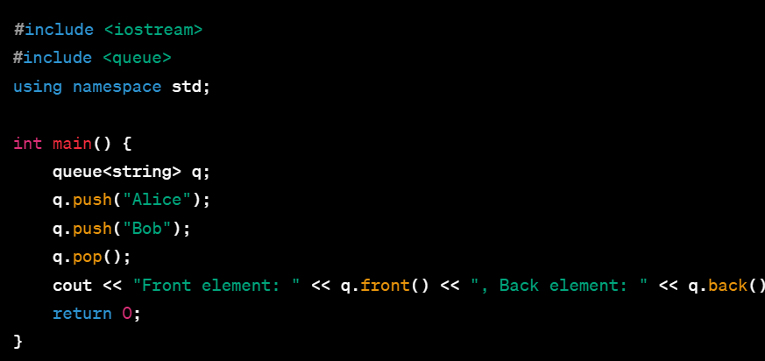

What is the output of the code snippet?

A) Front element: Alice, Back element: Bob

B) Front element: Bob, Back element: Bob

C) Front element: Alice, Back element: Alice

D) Error: 'back' function not defined for queues

Answer: A) Front element: Alice, Back element: Bob

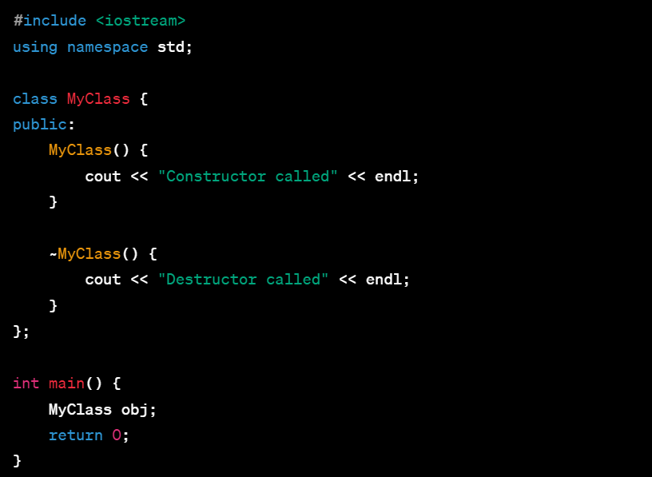

What will be the output of the code snippet?

A) Constructor called

B) Destructor called

C) Constructor called, Destructor called

D) No output

Answer: C) Constructor called, Destructor called

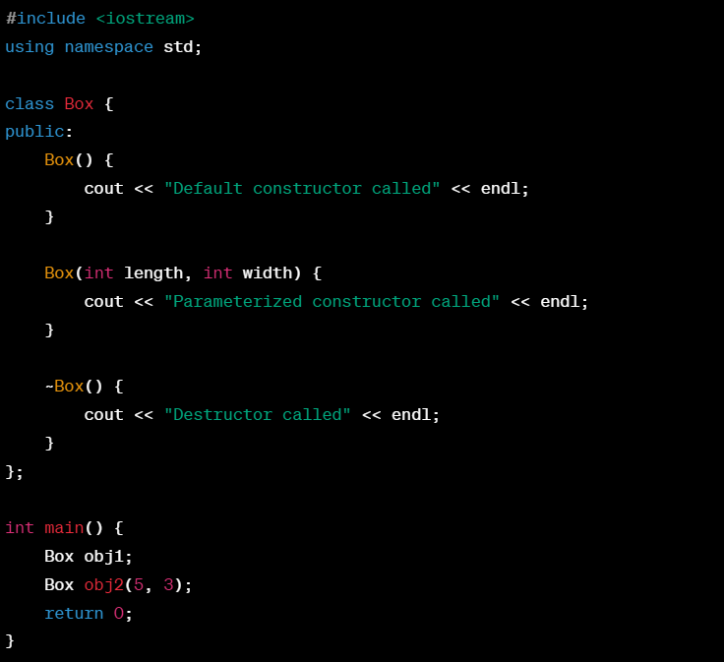

What will be the output of the code snippet?

A) Default constructor called, Destructor called

B) Parameterized constructor called, Destructor called

C) Default constructor called, Parameterized constructor called, Destructor called

D) Parameterized constructor called, Default constructor called, Destructor called

Answer: C) Default constructor called, Parameterized constructor called, Destructor called

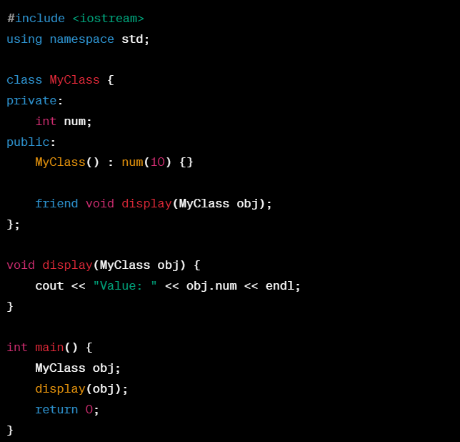

What will be the output of the code snippet?

A) Value: 0

B) Value: 10

C) Value: 20

D) Compilation error

Answer: B) Value: 10

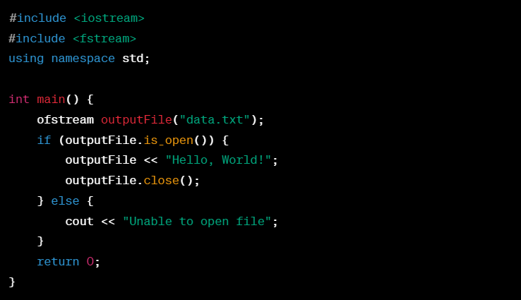

What will be the content of the "data.txt" file after executing the code snippet?

A) "Hello, World!"

B) No content in the file

C) "Unable to open file"

D) Compilation error

Answer: A) "Hello, World!"

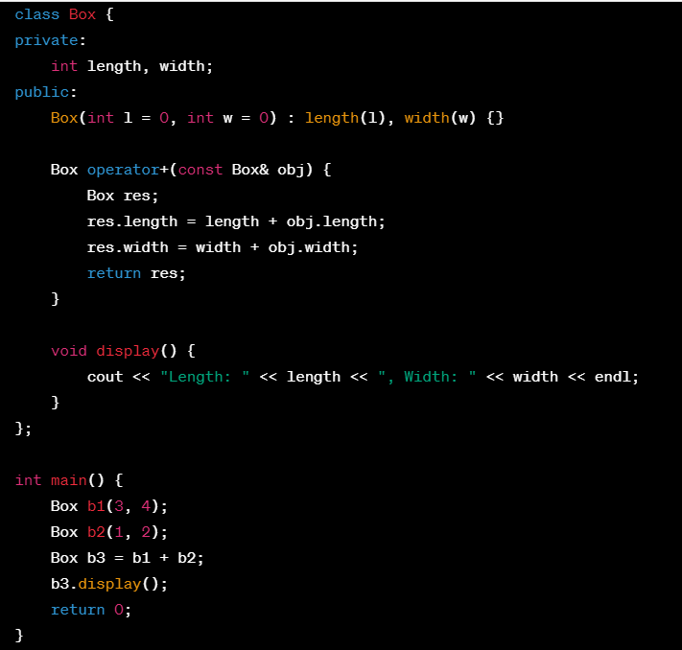

What will be the output of the code snippet?

A) Length: 3, Width: 4

B) Length: 1, Width: 2

C) Length: 4, Width: 6

D) Compilation error

Answer: C) Length: 4, Width: 6

Q17. What will be the output of the following C++ code?: #include <iostream>  
using namespace std;  
  
int main() {  
int arr[] = {1, 2, 3, 4, 5};  
int* ptr = arr;  
cout << *(ptr + 3) << endl;  
return 0;  
}  
A) 1

B) 2

C) 3

D) 4

Answer: D) 4

Q18. What is the purpose of using inline functions in C++?

A) To reduce code redundancy

B) To enable function overloading

C) To declare default arguments

D) To define recursive functions

Answer: A) To reduce code redundancy

Q19. Which of the following is NOT a valid way to provide default arguments in a C++ function?

A) Providing default values in the function prototype

B) Providing default values in the function definition

C) Using a separate function for default values

D) Providing default values in the function call

Answer: D) Providing default values in the function call

Q20. Which data structure is typically used to implement a stack in C++?

A) Linked list

B) Array

C) Queue

D) Heap

Answer: A) Linked list

Q21. What is the purpose of the 'try' block in C++ exception handling?

A) To catch exceptions thrown by the program

B) To handle the exceptions that occur in the program

C) To define the block of code where an exception might occur

D) To throw exceptions

Answer: C) To define the block of code where an exception might occur

Q22. The function that terminates the recursion process is referred to as the:

A) Anchor function

B) Starting function

C) Base function

D) Terminal function

Answer: C) Base function

Q23. What happens if a recursive function does not have a base case?

A) The function will execute indefinitely

B) The function will terminate immediately

C) The function will return an error

D) The function will throw an exception

Answer: A) The function will execute indefinitely

Q24. What is the advantage of using OOP?

A) Faster code execution

B) Smaller code size

C) Improved code organization and maintenance

D) Better compatibility with older programming languages

Answer: C) Improved code organization and maintenance

Q25. 1. What is the purpose of ifstream in C++?

a) It is used for writing to a file  
b) It is used for reading from a file  
c) It is used for both reading and writing to a file  
d) It is used for file deletion

Answer: b) It is used for reading from a file

Q26. Which header file is used for file handling in C++?

a) <filestream>  
b) <iofile>  
c) <fstream>  
d) <fileio>

Answer: c) <fstream>

Q27. What does the 'find()' algorithm in STL do?

A) Finds the first occurrence of an element in a container

B) Finds the last occurrence of an element in a container

C) Finds all occurrences of an element in a container

D) Finds the index of an element in a container

Answer: A) Finds the first occurrence of an element in a container

28. Which of the following statements about arrays in C++ is true?

A) Arrays cannot store more than 10 elements

B) Array elements can be accessed using index notation

C) Arrays can only store characters

D) Arrays automatically resize when elements are added

Answer: B) Array elements can be accessed using index notation

Q29. What happens if you try to access an element outside the bounds of an array in C++?

A) The program terminates

B) An error is displayed

C) The program automatically adjusts the array size

D) The value of the element is set to zero

Answer: B) An error is displayed

Q30. Which STL container allows only unique elements?

A) set

B) unordered_set

C) vector

D) list

Answer: A) set